**Project**

* Project is a unique process with clear boundaries (one beginning and one end), organizational framework (who belongs to the project and who does not) and implementation boundaries (what the project solves and what it does not solve). A project has a clear objective. The objective can be reached by creating some key products within the project.
* It is sensible to manage only such processes that are unique enough. Not repeated things.
* **Project is a sequence of activities with a start and an end, and allocated resources, directed to the creation of certain products or services.**
* Project is a vehicle for changing the flow of events
* Project usually comprise of **stages**
  + A stage isa time period in which something complete is produced
  + Stages follow sequentially
* Project Management can be viewed in terms of phases
  + Each Project Management Phase is characterized by its own special approach
* Project is about value co-creation

**Program** = multi-project

* solution to complex projects is recursion
* projects have a common goal

**Portfolio**

* a means for management of a collection of Projects and/or Programs

**Benefit ≠ Objective**

* Benefit is a profit that results from using achieved project objectives.
* Objective is a description of a state after the implementation of a particular change (e.g., description of services, products, piece of work, etc.)
* Objective is a set of deliverables

**Service**

* Service is an intangible phenomenon which could be one-shot or repeating activity bringing directly a benefit for its Client.
* Service is provided by a Provider for a benefit of the Client by transforming or operating on a Target.
* Service cannot be owned, nor stored.
* To provide a Service a kind of co-operation between the Client and the Provider is needed.

**Service System** defintion

* Service system is a composite of agents (including both, people and artificial ones), technology, environment, and/or organization units of agents and/or technology, functioning in space-time and cyberspace for a given period of time.
* A composition of compositions of ***People***, ***Technology***, and ***Information***, providing benefits to recognized clients – in particular contexts.
* It comprises ***service providers*** and ***service clients*** working together to co-produce value in complex value chains or networks.
* There is always lot of contexts from which the service system could be evaluated, explicated and comprehended.
* every entity is a SS (individuals, families, firms, nations, economies...)
* A sequence of events in C-vertex is different from that one in P-vertex and both are different from that one in T-vertex.
* But combining these three into one SS\* gives them “a common history” for a non-trivial time interval
* An ‘object’ itself has no value without evaluation the cost invested into it; the value arises when the object is pushed to action—when a service occurs
* Thinking on C-P-T and on benefits for the ‘C’ help us understand situations better and help us not to be bumpkins in many states of affairs
* Service systems and PPP
  + Service System behavior can be effectively described by means of
  + Projects
  + Programs of projects
  + Portfolios of projects or programs or (another) portfolios
  + Key questions:
  + What are the benefits?
  + What is the value?
  + Is it worth to invest?
* how to deliver benefit to customers
  + This, what directly is, or can be, useful, i.e., which directly brings or can bring benefits, is a SERVICE
  + … not a PRODUCT nor a PROVIDER / PRODUCER
  + SERVICE is the benefit making element
  + Two possible paradigms exist in business:
  + PRODUCT oriented
  + SERVICE oriented

**PPPM = Project-Program-Portfolio Management**

* Agent operating on Target needs Technical competences
* Agent dealing with Environment needs Contextual competences
* Agent dealing with humans needs Behavioral competences

**Learning cycle of Service System (MENTION-USE principle)**

**PMI = Project Management Institute**

* Process oriented
* 9 groups of processes
* Each group called “knowledge area”
* 44 processes grouped into 9 knowledge areas
* Much more like a “cookbook”
* Input > Transformation > Output fashion
* Concerned more on **HOW** then on WHY and WHAT
* Very useful when training people to do their work well
* The standard is manifested in the so called **PM BoK** = Project Management Body of Knowledge

**IPMA**

* Competences oriented
* Three groups of processes
* 46 competence elements
* Much more like a “definition”
* Specification + possible steps description fashion
* Concerned more on **WHAT and WHY** not on HOW
* Very useful in cases of unusual, complex and very new situations
* The standard is manifested in the so called **ICB** = IPMA Competence Baseline
* four level certification system
* Contextual competences
  + TODO
* Behavioural competences
  + TODO
* Technical competences
  + TODO

**Process groups (Project management phases)**

**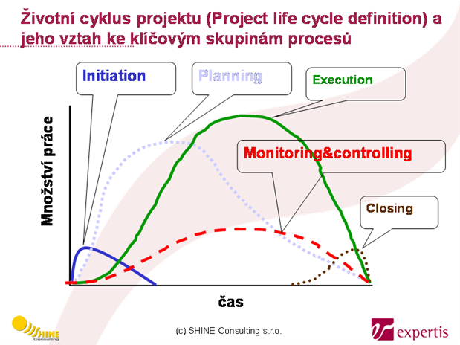**

* Initiation
  + *What to do?*
    - Reasons for project initiation
    - **The tripple constraint** – WHAT or (WHEN and FOR HOW MUCH) => not able to fulfil all 3
  + *How to do it?*
    - Preliminary project charter
      * allows the organization to start project management of the given matter;
      * is the first definition of the **scope** of a new project;
      * further elaborated into the so called “Project Charter” that defines formally the initiation of a new project
    - A case study
* Strategy
  + represents an agreement between a project CLIENT and project PROVIDER, defining responsibilities of each
  + Answers questions: Why to implement? What are benefits? What are objectives? What is the environment like? What are the risks?
  + *What to do?*
    - Factual and organizational boundaries of a project
      * WHO participates?
      * WHAT is the solution content?
      * WHICH products imply achieving the objective?
    - Definition of project success metrics
      * HOW can we recognize we have reached the objective?
    - Definition of decision making boards
      * WHO controls WHOM?
  + *How to do it?*
    - Organization structure of a project
      * main bodies:
        + Steering committee

client – user of deliverables, payer

provider – project author, project administrator

* + - * + Project management team – project author, project administrator
        + Implementation team – employees of the Provider, (employees of the Client)
        + Support team – employees of the Client
    - Logical Framework Matrix
      * + conditions/assumptions = outer world – if we fulfil them, we obtain higher level
        + measurements/indicators – tell us whether the entity was achieved
        + measurements/indicators resources – how to obtain data for indicators (where is the source)
        + assumption ≠ reality – necessary vs. real state of the world
    - Risks analysis
    - Strategy revision based on risk analysis results
* Planning
  + There needs to be clear distinction between WHAT and HOW
  + *What to do?*
    - Plans
      * help to shape a common vision of the situation
      * specify the project scope
      * basis for determining amount of effort needed
      * WHAT (RESULT) – the most important
      * HOW (PROCESS)
      * WITH WHOM (RESOURCES)
      * WHEN (TIME)
      * FOR HOW MUCH (COSTS)
  + *How to do it?*
    - A key aspect of planning
      * Idea: How often we start to explain and defend HOW to solve a problem before agreeing on WHAT actually the problem is?!
      * Climber vs Tourist
        + Mountain climbing is not our objective, the goal is to bring the flag to the top
        + Change the process (HOW) in order to reach WHAT.
    - WHAT
      * Work Breakdown Structure (WBS)
        + hierarchical analysis of project deliverables
    - HOW
      * Project Chart
      * What activities and in what logical sequence will create project products.
        + It is important not to include time perspective or resource availability into the process!
        + It is acquired by elaborating WBS and by its ordering into the logic of a sequential execution of activities
    - WITH WHOM
      * what resources we will need
      * how to fill them with people
        + in the what plan – person guarantees deliverable
        + in the how plan – team members create deliverables (do the process)
    - WHEN
      * activity starting date
      * activity ending date
    - FOR HOW MUCH
      * what plan – material, products, services to purchase
      * how plan – work load, cooperating companies
* Implementation
  + There needs to be clear distinction between WHAT and HOW
  + *What to do?*
    - What is managed
      * scope/configuration
      * process
      * quality
      * risks
      * changes of all the above
    - The management principle (cycle)
      * proposal of a new plan
        + focus on WHAT and WHY, not HOW
        + do not make an effort to fulfil original plan, but make a new one
        + bear in mind what is decisive axis of the triple constraint and what are the benefits
      * task assignment
      * work on the project
      * state evaluation
        + current state vs. plan
        + is it possible to achieve expected benefits?
  + *How to do it?*
    - How to start implementation?
      * FORMING
        + meet provider team > meet client
        + discuss triple constraint and benefits, process, products, metrics, roles, communication standards, work standards, documentation models, risks
    - Best management practices
      * The management principle
        + control meeting

process – progress

scope/quality – degree of product completion, discovering inter-product dependencies

risks – current, new

* + - * + planning meeting

scope/quality – new scope and quality (the WHAT plan)

process – new HOW, WITH WHOM, WHEN plans

risks – plan of eliminating risks

* + - Management of multiple projects – the principle
      * Two-level management structure
      * Program management cycle
        + Outer loop

Define organizations strategy – objectives set by senior management, non-financial objectives

Collect and evaluate candidate programs

Select and prioritize candidate programs – evaluate in terms of investments, benefits, risks, timescale, alignment with objectives

* + - * + Inner loop

Initiate selected programs

Define projects to deliver programs

Initiate projects

Manage program and projects

Close projects

Close programs

Deliver and monitor benefits

* Handing over
* Evaluation
* Conclusion

**Service Science Master’s program**

* T-shape professional – proposed guidelines for evaluating a Service Science Master’s Program
* A Service Science Master’s degree is an advanced degree in any discipline and service system which is grounded in a single discipline (such as engineering or business) while also developing the students’ ability to understand and communicate across / among multiple disciplines.
* The program overall must be multi-disciplinary.
* It must provide an integrated educational experience in a *context of Services* that develops the ability of graduates to apply pertinent knowledge to solving problems working across / among multiple disciplines and service systems.
* The notion of value co-creation is important to cover as well as using cases and examples about services
* Program outcomes
  + professional skills/abilities
    - to lead multi-cultural and virtual teams
    - to work within a project management structure
    - to understand responsibilities
    - to use multiple communication mechanisms, reports
    - to utilize the appropriate literature
  + attitudes
    - recognition of the value of collaboration, ability to collaborate
    - recognition of the need for lifelong learning
    - respect for diversity
    - commitment, to quality, timeliness, improvement and innovation
  + disciplinary field and Service System
    - able to understand and communicate across the areas of technology, people and business
    - able to demonstrate analytic thinking and problem solving (within one discipline and for one or more system)
* Service System (cont.)
  + A ***system*** is a set of entities involved in relationships and interactions.
  + We think of ***service systems*** as dynamic human centred value co-creation systems.
  + These are “real world application” of disciplines.
  + Every day nearly every person is a customer explicitly or implicitly of the following groups of systems:
    - Systems that meet routine daily needs for everyone (moving material, energy, information)
    - Systems for people's life planning (places and life-styles services)
    - Systems for governing (public services, rules and policies)
* 3 pillars of modern society (disciplines)
  + people
    - Government, political science, law, sociology, ethics
    - Human factors engineering
    - Organizational science, leadership
    - Psychology, cognitive science
    - Learning science, strategy
    - Service marketing, behavioral science
  + technology
    - Computer science
    - Information science
    - Decision science, data mining & analysis
    - Systems engineering
    - Systems science
    - Other engineering
  + business
    - Innovation management
    - Project management
    - Service design
    - Service operations
    - Business management, process management, service management
    - Economics, finance
    - Ethics
* SSME:
  + Integration of competences
  + Understanding/communication cross disciplines
  + Understanding/communication cross systems
  + Deepens of competences in at least one discipline
  + Deepens of competences in at least one system

**DEsigning Lifelong Learning for Innovation in Information Services Science (DELLIISS)**

* (EISS) Engineer of Innovation in Service System’s key competences:
  + Periscopic Competences
  + PPM Competences
  + Promotion of Innovation Competences
  + Service Design Competences

**S-R-O-D**

* a possible thinking pattern to be usable in Service Systems
* Toward Effectiveness, Efficiency, Sustainability
* How to apply the holistic approach
* How to see the connections
* SEE
  + Playground: Diamond of Attention Focusing
    - DIAM_1_Attention
* RECOGNIZE patterns
  + Execution rules: Diamond of Cognitive Elements
    - DIAM_2_cognitive_elements
* ORGANIZE
  + Player’s organization: Diamond of organization
    - DIAM_3_Organization
* DO something to survive
  + Action: Diamond of Predictive Behavior
    - DIAM_4_full_plus

**Value Proposition**

* A valid statement is necessary between ‘C’ and ‘P’ about “**what**/**how**/**where**/**who**/**when**/**why**”   
  will be done during the service performance.
* This negotiation has to be maintained and revised continuously through the service provision life-cycle.
* Through all the **process of service provision** there must be at any time point valid statement of work declaring *what* have to be done, *how* it will be done, *where* it will be done, *who* will do *what*, *when* *what* will be done, and *why* it will be done. This statement is called a **value proposition**.
* **target =** a part of reality to be transformed
* characteristics
  + Absolutely clear for all stakeholders
  + A benefit for the Client must be obvious to this level that he buy in to the change!
  + A clear “axe edge” to cut up the problem has to be recognized and communicated.
  + The “axe edge” is about **usefulness** for Client or potential clients.
  + Any particular usefulness claimed in VP has to be supportive to this “axe edge”.
* why it is important
  + A service provision is about change.
  + Everybody has his/her/its own filter, set of filters precisely, by which filters the whole stream of data when perceives.
  + There is lot of contexts from which each particular situation could be understood and evaluated.
  + Law of inertia (zotrvačnosť) works in society as well as in nature.
  + Thus to convey clear “what/why/how to change” is necessary to put ideas to action.
* recommendation
  + Two kinds of change exist according to the Gerald Bradley’s book ‘Benefit Realisation Management’, GOVER, 2006:
  + Change acquiring and/or implementing capability (***enabler***)
  + Change embedding this capability into the working practice (***business change***)
  + Namely the VP for ‘business change’ is the issue, as Clients live in the working practice.
  + And moreover, Clients’ contexts are entirely different from the context of a Provider who understands well the ‘enabler’.
* how to formulate
  + Key stakeholders identification and classification
  + Target (“T” from C-P-T) clear definition
  + Benefits for C recognition
  + “Enablers” and “Business change” specification (see “BRM”)
  + Deliverables description
  + “Axe edge”-like formulation
  + Revision of all points
  + Workshop (forming seminar) with key stakeholders at the start and/or end of the process

**Service System boundaries**

* are artificially created in accordance with pragmatic reasons
* Two Legs Principle
  + The biggest enemy of Project/Program/Portfolio management is absence of boundaries and absence of cognition
  + That is why they both, cognition and PPPM have to go together! … so as we are going using our two legs …
  + The “TLP” has more manifestations, e.g. **a**cademic and **b**usiness world; I call it “way A” and “way B”.
  + … again boundaries between them are artificial, only
* Prime Service System
  + there is only one context involved in which the roles of Client, Provider, and Target are spread on Agents
  + all the time the Service System is alive the role assignment does not change
* Co-operative Service Systems
  + the following conditions hold:
    - C1 = P2
    - P1 = C2
    - a benefit of C1 (C2) depends in a way on the benefit of C2 (C1)
  + Note that no constraint is done on targets of those systems.
* Dual Service Systems
  + it holds that:
    - C1 = P2 and P1 = C2
    - T1 = T2
    - value proposition of (C1,P1,T1), formulated within the first context, and value proposition of (C2,P2,T2), formulated within the second context, are formulated such that their union creates a two-directional value proposition covering benefits for both C1 and C2
  + than we deal with (C1,P1,T1) and (C2,P2,T2) as it is one SS\* with two contexts

**Breakdown Structures**

* To construct a new complex service from several simpler services
* To solve CEP = Complex Event Processing
* To be able to understand deeply a VP
* To be able to formulate VP based on deep understanding
* The WHAT plan can be broken down using the Fundamental Hierarchy Pattern
* Breakdown Imperative: If you start to breakdown X, then continue with X and finish with X. The X could be:
  + Work, Product, Deliverable, Object, Activity, Organization, Goal, Service, VP
* do it from top to bottom by using the right questions

**Theory of Constraints**

* one place within the possible solution space is “the most retarding” – have to use it to the fullest
* 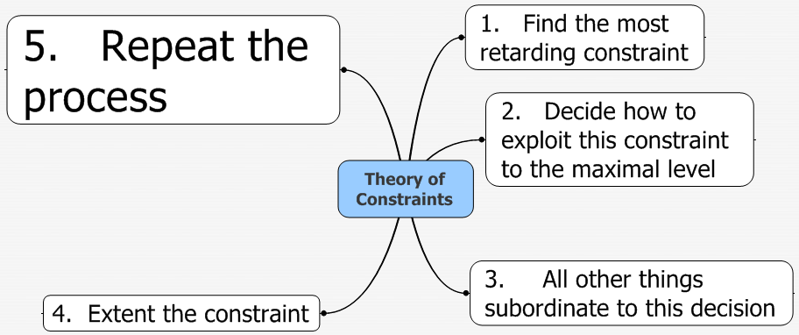
* the most retarding component in PPPM are resources
* situation when one project affects the other projects:
  + reduce multitasking of critical resources
  + milestones doesn’t help (student’s principle)
  + critical path - path in a network graph which has the longest duration. It consists of critical activities. Delays of any of the activities on a critical path lead to a delay of the whole project.
  + critical chain - such sequence of depended activities from various projects of a program or a portfolio, which constraints to finish a project or a set of projects early, with the same set of resources

**Rope and Drum Principle**

* The work must not be pushed through a team of agents !
* The work must be pulled through a team of agents !
* The work must be done in a regular rhythm !

**Shared Value Creation**

* The law of Creating Private Value + Creating Shared Value co-opertion
  + law of sustainability of both the individuals and the society
  + impact on the 3 pillars of modern society
    - people
      * change of behaviour and change of mind
      * sum of individual messages is less than co-created message
    - technology
      * some parts are my problem, some of them I can obtain as a service
      * step-by-step extension and improvement of the service
    - business
      * how to sell a good and useful solution?
        + how to explain a non-monetary value?
      * problem:
        + we are living in the world with asymmetric distribution of information
        + the presumption of the market value balancing by the market is no more valid

**Organizing Programs, Business Units and other Service Systems**

* Leadership “from the front”
  + A commandment of successful innovative research project/program:
  + Leadership and decision-making is conducted by individuals possessing relevant expertise and relevant context of the Program and understanding deeply this context.
* Success in a Program
  + Make things bringing added value to deliverables of a program (\*-processes)
  + Think of the \*-processes and make things which help to improve the \*-processes
  + Assure you have a strategy, everybody knows the strategy, everybody shares the strategy
  + Create strategy in a form of “strategic continuum”
* research project
  + Floating project Scope
  + Only vision is fixed
  + SBS is very dynamic
  + Work load is dynamic and unpredictable in details
  + Project milestones are time fixed, only
  + The funding is usually not clear …
  + Double-level management: research project is managed as a program
  + Rules and understandable measures
  + Motivation: Attention function (“credit function”) – measure of team-member attention relative to the whole project attention
* TODO – end of presentation L10 from slide 19
* TODO – lecture 12